INDEX

TITLE

Chapter1
1.1 Introduction
1.2 Objectives
1.3 Problem Statement
Chapter2:Literature Review
Chapter3:Data Collection
Chapter4:Methodology
4.1 Exploratory Data Analysis
4.2 Statistical Techniques and Data Visualization
4.3 Data Modeling Using Supervised Learning Algorithm
Chapter5: Findings And Suggestion
Chapter6: Conclusion

CROP PRICE PREDICTION

1.1 Introduction:

During 1960s, the shortage of food and excess of demand of food grains is due to the government policies on agriculture and other government mechanisms evolved in India . Certain rules were introduced like system of procurement and distribution of major food grains and statutory minimum prices were set even though it was not strictly implemented. There are three main agricultural price policy in India which includes: support, procurement, and issue price. Usually during the sowing time the minimum support price is announced, and the government completely takes the responsibility to sell the crops at the prescribed price. The prescribed prices guarantee to the farmer that, if there happens to be mass production leading to oversupply in the market, the value of crops what farmers have produced will not fall below the support price. Support prices effect the farmer indirectly when the famer decides on which soil to grow his crops, ultimately the location matters a lot. Based on the quantity of crops that were grown previous year the farmers decide in which areas what type of crops to be sowed. Based on government’s needs for the distribution of crops in public the quantity to be procured is determined.
From past few years, the total quantity produced is total dependent on the grain that is put up on sale by the farmers at a price that is fixed by the government. The support prices are lesser than the these government fixed prices but the free market prices are much more higher than the fixed ones. During a good harvest, the market prices would be lower, but tends to run higher than the procurement prices once the surplus is cleaned up completely. The importance of reasonable prices to the farmers is known by the government, hence motivating them to use improvised technology and also promoting investments for an increased production of agriculture. In India, the agricultural pricing policy has a price structure that is quiet balanced which has the ability to fulfill all the requirements of the Indian economy along with the protection of both the producers and consumer’s interests.
The main aim of the above mentioned policy is to help to provide a suitable approach towards achieving the growth and equity for the economic development of India. The minimum support prices which are used as the incentive prices are really useful for the successful running of the agricultural production based programs which is based on technologies that help in high yielding of the crops. Similarly, for the high production of food grains, the undue dependency cannot be put onto the environment of increased prices as an incentive. Adequate institutional arrangements are required for price support policies and its implementation so that purchase of quantities is offered for sale at that price itself. The market price for any kind of product or services is found out by the demand and supply interaction because in an Indian market, price can never be under control. This shows the willingness of the consumer and the producer to buy or sell a particular product respectively.
1.2 Objectives
- To assess the scope and suitability of machine learning methods forυ predictions of crop price
- To develop initial machine learning models for crop price predictions
- To analyze the performance of the model developed
- To explore the spatial & temporal granularity, and constraints therein in the database

1.3 Probelm Statement
In India 49% of population depends on Agriculture, which plays an important role in Indian Economy. Agriculture contributes only 19% of GDP, hence the rural youth is moving away from agriculture to other sectors. In-order to achieve a dream of developed India we need to boost our agricultural policies. The main reason why the farmers are moving away from their occupation is due to lack of technologies, lack of transparent mechanism for deciding MSP and lack of communication channel between policy makers and famers. So the focus is on to develop a portal which can solve the problem of pricing policy and role of farmers in policy making.

2.Review Of Literature

Literature survey plays a very important role in the project development. Literature survey provides the required knowledge about the project and its background. It also helps in following the best practices in project development. Literature survey also helps in understanding the risk and feasibility of the project. The feasibility of the project depends upon the risk of the project. If the resources, time and money are not available for the project development, then the risk is higher. Literature survey also gives light on various tools, platforms and operating systems suitable for project development. Once programming begins then the programmers require a lot of support and advice.
- In this paper, author describes the capabilities of various algorithms in predicting several weather phenomena such as temperature, windy, humidity, rainfall these parameters concluded that major techniques like decision trees, artificial neural networks, clustering and regression algorithms are suitable to predict weather phenomena. This shows that the decision trees and k-means clustering are best-suited data mining techniques for this application .
- Many authors conclude that classification and summarization are the two main data mining techniques widely use in Weka and Rapid Miner tool for weather forecasting.
- In a prediction model of vegetable price was set by applying the neural network based genetic algorithm. Taking mushrooms price as an example 3.Data Collection
Crop prices are affected by several factors such as climate, supply and demand. It is very difficult to collect data based on these factors; we take only the most permissible crop price as experimental data. For long time forecasting, daily frequency data is preferred. Monthly data are used for forecasting because it has less noise. In this study turmeric, cotton price data from JAN 2005 to DEC 2013 are taken for creating the model. For simulating the model, previous month’s price of crops from Erode and Salem market was considered and later few monthly prices was considered as test data for the model
4.Methodology

Multi Linear Regression
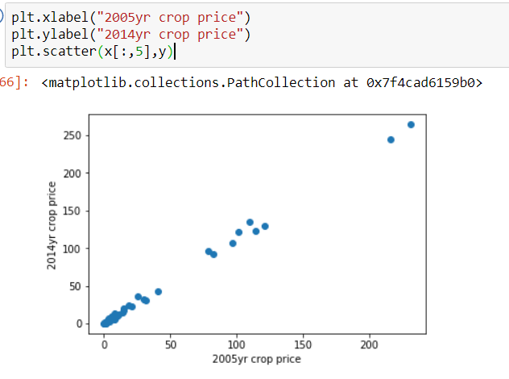
The difference between simple linear regression and multiple linear regression is that, multiple linear regression has (>1) independent variables, whereas simple linear regression has only 1 independent variable. In this project, Multiple Linear Regression algorithm is used to predict the crops. Multiple Regression is an extension of simple Linear Regression. It is used when we want to predict the value of a variable based on the value of two or more other variables. The variable we want to predict is called the dependent variable (or sometimes, the outcome, target or criterion variable). The variables we are using to predict the value of the dependent variable are called the independent variables (or sometimes, the predictor, explanatory or regression variables). For example, Multiple Regression to understand whether exam performance can be predicted based on revision time, test anxiety, lecture attendance and gender. Multiple Regression also allows you to determine the overall fit (variance) of the model and the relative contribution of each of the predictors to the total variance.
Formulae:
A Linear Regression model that contains more than one predictor variable is called a Multiple Linear Regression model. The following model is A Multiple Linear Regression model with two predictor variables, 𝑥1 and 𝑥2 .
𝑌 = 𝛽0 + 𝛽1𝑥1 + 𝛽2𝑥2+ ∈
Where,
𝛽0, 𝛽1, 𝛽2 … are coefficients of Multiple Linear Regression
𝑥𝑖1, 𝑥𝑖2 ... are independent variables.
The model is linear because it is linear in the parameters 𝛽0, 𝛽1 and 𝛽2 . The model describes a plane in the three dimensional space of 𝑌, 𝑥1 𝑎𝑛𝑑 𝑥2 . The parameter 𝛽0 is the intercept of this plane. Parameters 𝛽1 and 𝛽2 are referred to as partial regression coefficients. Parameter 𝛽1represents the change in the mean response corresponding to a unit change in 𝑥1 when 𝑥2 is held constant. Parameter 𝛽2 represents the change in the mean response corresponding to a unit change in 𝑥2 when 𝑥1 is held constant
Accuracy Measures:
Multi Linear Regression algorithm is used in this research work. Experiment is performed by using r2_score.
Procedure:
- Eight years data considered
- Eighty percent for training and 20% for testing
- Correlation and mean square error calculated
- Validation done using 20% dataset
- Values of Y are predicted using test set
- Models generated separately for the 2 locations
- Accuracy score is calculated

4.1.Exploratory Data Analysis

4.1.1. Figures and Tables
Dataset used:
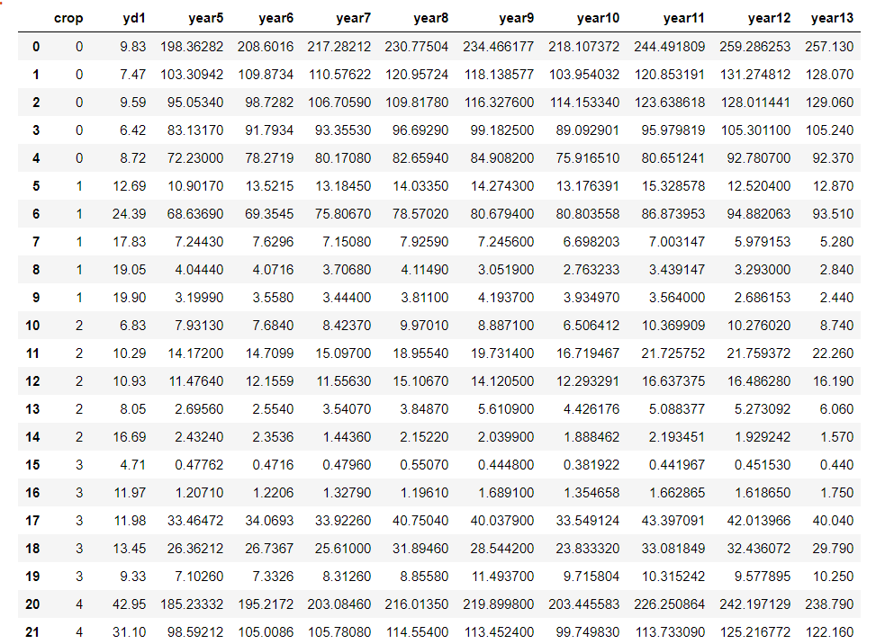
4.2 Statistical techniques and data visualization:
By importing matplotlib.pyplot library we have drawn graphs. We have visualized the percentage. And we have used the co-relation function to demonstrate the impact of every factor on each other.

Correlation graph(Heat map):

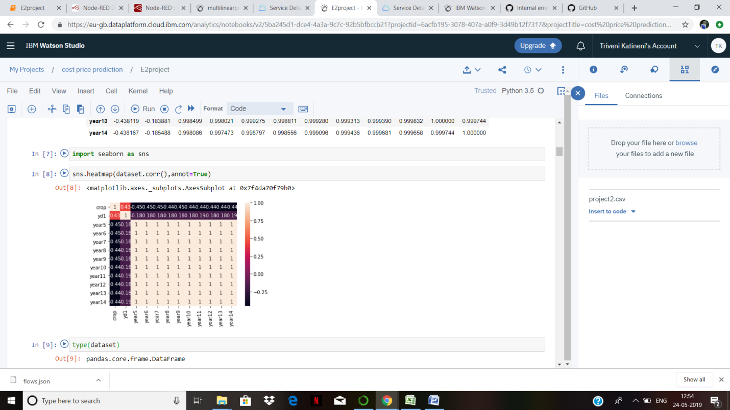

4.3 Data modeling using supervised learning algorithms:
In general we have two types of learning algorithms, supervised and unsupervised learning algorithms and in detail it consists of different techniques like, Multi Linear Regression
Since our model comes under supervised learning algorithm we applied every technique, of the algorithm and based on the accuracy values we obtained we chosen Multi Linear Regression and our model has dependent variable which is Efficiency means the output can be the performance of data cent

5. Findings and Suggestions
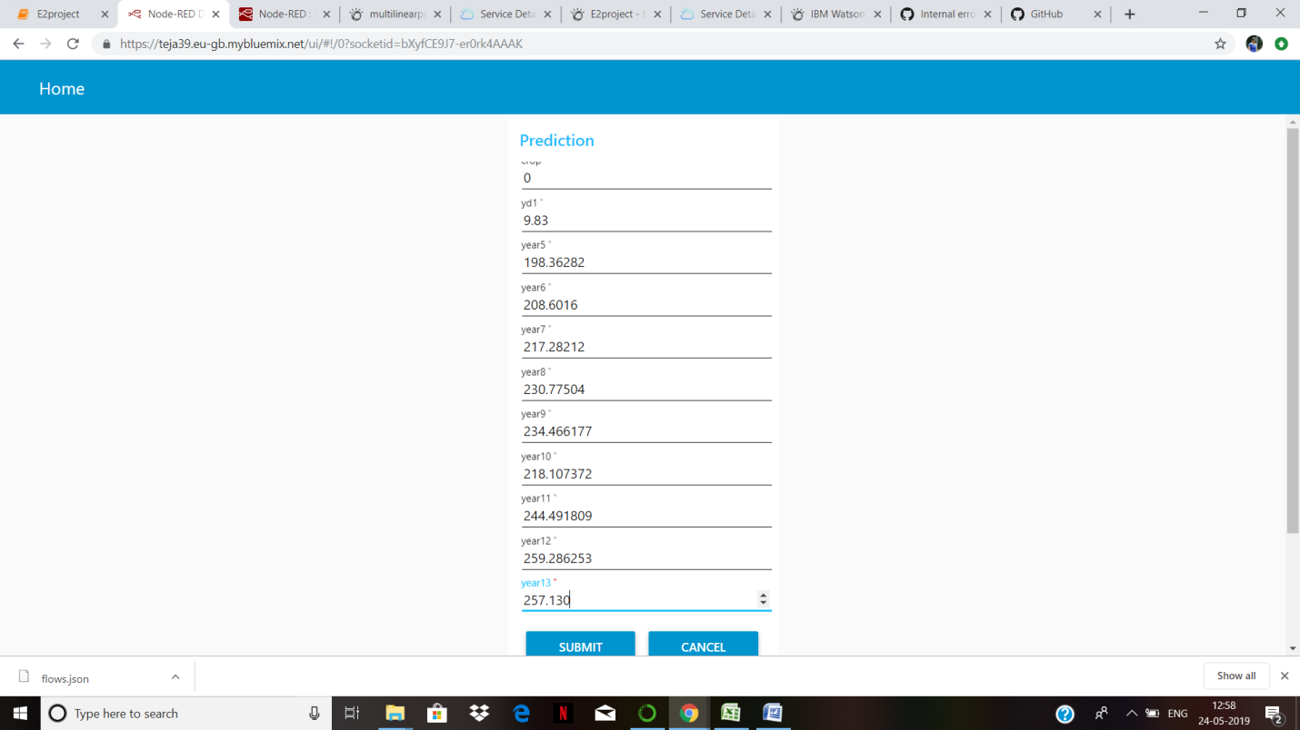

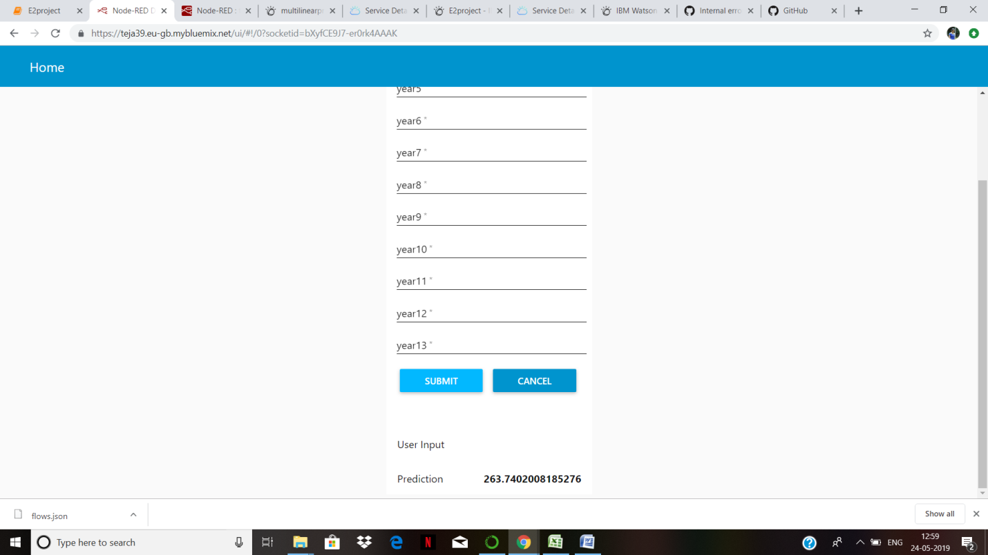

6.Conclusion
According to the survey what is been done, there are still chances that the result might get improved. During the research which we have carried out it is observed that the most of the algorithm and methods which is been used by most of the authors does not use a collective approach where all the factors that affect the crop yield can be simultaneously be used for predicting the yield and hence deciding the price of the crop. There can be further improvements because in some analysis very few amount of datasets have been used. Therefore the result can be improved by using a large dataset. Larger the datasets the better the results are. During calculation of prices role of farmers could be extended and a system can be build which is more transparent and accessible to farmers. A methodologically calculated msp would reduce the role of intermediates in selling of crops as farmers will have better picture of value of their production
The future work would be as follows:
1) Automatic integration of changes made by the government in the MSP policies to be updated automatically into the portal.
2) Provide transperancy by providing the portal in all the indian languages.
3) Build a communication bridge between the farmers and the government regarding the discussion of MSP policies and prices though sending and receiving of messages..

